Background:

Welcome to the course!

Students will need to create their own AWS account for the exercises and projects in this course. In class, we reviewed billing alerts and free tier assets. All students need to create new AWS accounts using their Gannon email address. This ensures you have a full year of free tier and might help if you need charges to be forgiven due to student error by AWS support.

The exercises and projects for class are designed to use the free tier and to limit cost to students. The instructor and Gannon University are not liable for excess usage of AWS services.

**\*Your unique AWS Account ID must be in screenshots for validation purposes.**

**\* We will use US-EAST-2 (Ohio) for this course unless otherwise specified**

This initial assignment is worth 25 pts of your course grade.

*The content below references the text book for the course. It is expected that you purchase the required course materials.

**Problem 1: Create an AWS account (5pts)**

**P1: Task #1 Create an AWS Account**

1. Go to https://aws.amazon.com, and choose the Create an AWS Account button. If, instead, you see a Sign In button, you might have previously logged into an existing account using this browser. If you’d still like to create a new account, choose Sign In and then create a new, different account.
2. Enter the email address you want to associate with the account, a (strong) password, and a new AWS account name you’d like to use. Choose Continue.
3. Select an account type (either Professional or Personal—the only difference is the Company Name field) and the other requested information. Then agree to the AWS terms and choose Create Account and Continue. You will receive a confirmation email, after which you can continue with the activation process.
4. Enter a payment method and, if the payment address is different from the address you used in the previous step, enter a new address and choose Secure Submit.
5. On the Phone Verification page, enter the phone number AWS can use for an auto- mated authentication call. After you choose Call Me Now, enter the PIN that will be displayed in the browser page on your phone’s keypad.
6. One last step: on the Support Plan page, select an AWS support plan. Go with the Basic plan for now. It’s free, and you can always upgrade later. You’ll learn more about AWS support in Chapter 3, “Getting Support on AWS.”

*Once you’re fully activated, you’ll receive another email, this one confirming that your account is ready for you.

**Please fill in to complete the exercise**

Student Name: Kunga Nyima Gurung

Gannon Email: gurung019@gannon.edu

Screenshot of login to AWS account with AWS Account ID showing:

AWS Account ID: 977099007886

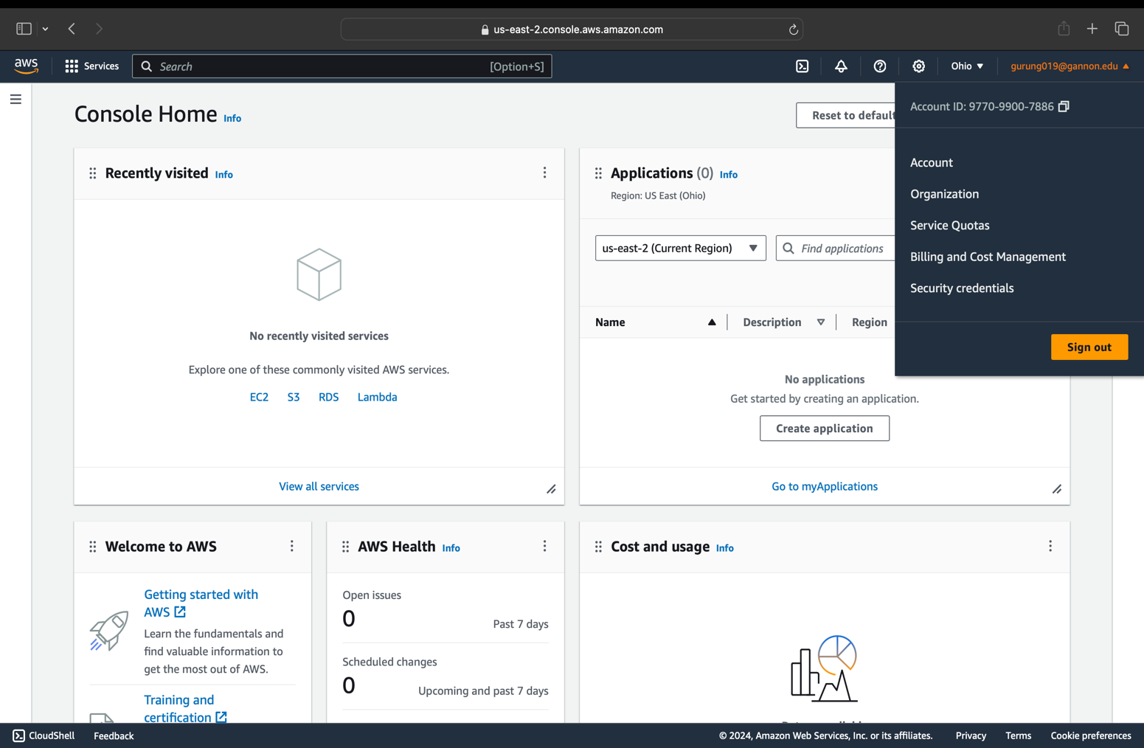

P1: Task #2: Create a cost budget to Track Spending

In this exercise, you’ll configure a budget that will alert you by email whenever your monthly account spend threatens to exceed your limit. This can be particularly useful to protect your account against an attack that launches unauthorized resources:

1. While logged into your account as the root user, choose Create Budget on the Budgets page and select Cost Budget.
2. Give your budget a name, leave Period at Monthly, and enter a Budgeted amount that’s a bit higher than the maximum monthly spend you want to permit your account ($20 USD). You can leave the rest of the settings at their defaults, which will track all account costs. Choose Configure Alerts.
3. Leave the Alert Based On value as Actual Costs, and add a percentage of 80% to the % Of Budgeted Amount field. This will trigger the alert when your actual monthly spend hits 80 percent of your maximum.
4. Enter at least one email contact, and then choose Confirm Budget. Review the settings and, if you’re happy, choose Create.

*Setting this budget alarm will ensure that you are notified if usage exceeds the free tier level.

**Please fill in to complete the exercise**

Student Name: Kunga Nyima Gurung

Gannon Email: gurung019@gannon.edu

Screenshot of login to AWS account with AWS Account ID showing:

AWS Account ID: 977099007886

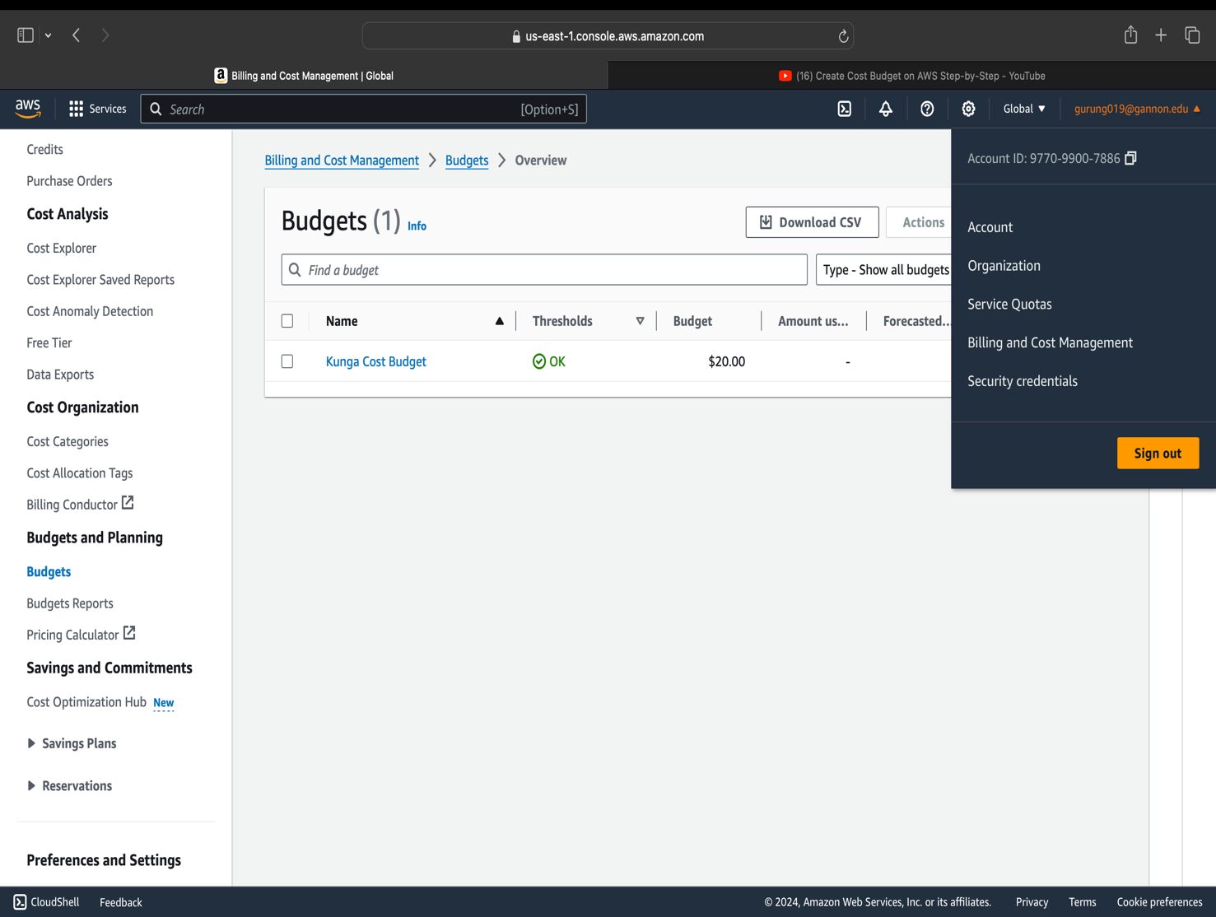

**Problem 2 (5pts)**

**P2: Task #1: Calculate monthly Costs for an ec2 instance (pg. 19 of the text book)**

Even though you may not yet fully understand EC2 instances—that’ll come in Chapter 7— try using the EC2 pricing page to figure out how much it would cost you to run an on- demand compute-optimized c5.18xlarge instance type with a 20 GB EBS storage volume in the US East region.

1. Open the EC2 pricing page (https://aws.amazon.com/ec2/pricing), and select See On-Demand Pricing.
2. Select the US East-2 (Ohio) region.
3. Select the Linux tab.
4. Scroll down the list until you get to the c5.18xlarge line. Note the Per Hour value.
5. Multiply that value by 750, which is (more or less) the number of hours in a month.
6. Open the EBS pricing page (https://aws.amazon.com/ebs/pricing), and select the US East (Ohio) region.
7. Find the Amazon EBS General Purpose SSD line, and note the Per GB-Month value.
8. Multiply that value by 20 (the desired size of your storage volume), and add that to the EC2 instance type value.

**Please fill in to complete the exercise**

*Please provide the values calculated as instructed above

2295 and 1.6 respectively

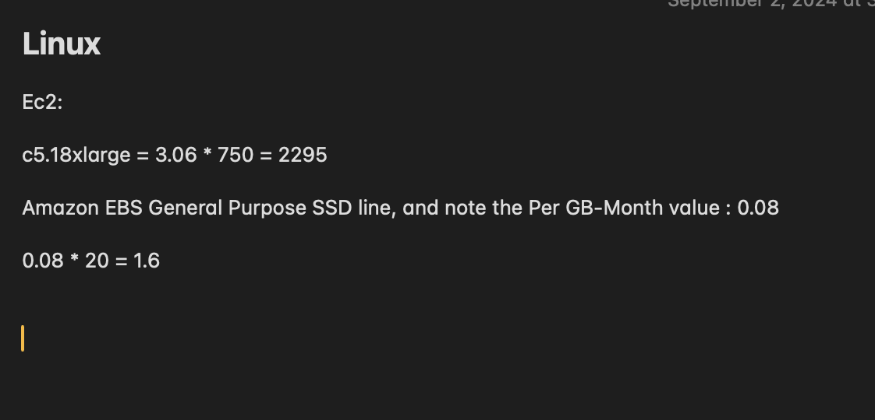

**Problem #3 (5pts)**

**P3: Task #1: Create an Admin IAM User with Admin Permissions to work with for future labs**

*Follow the AWS Documentation for creating a new IAM Admin User and Group for use instead of the root user for your new AWS account after this exercise.

<https://docs.aws.amazon.com/IAM/latest/UserGuide/getting-started_create-admin-group.html>

*All screenshots must have your AWS account ID at the top

- Login as your new root user

- Select IAM from the top menu

- Create a user, group, attach AWS admin policy to group, attach group to user

- Login as your new IAM user and make sure you have admin access by selecting IAM from the services menu

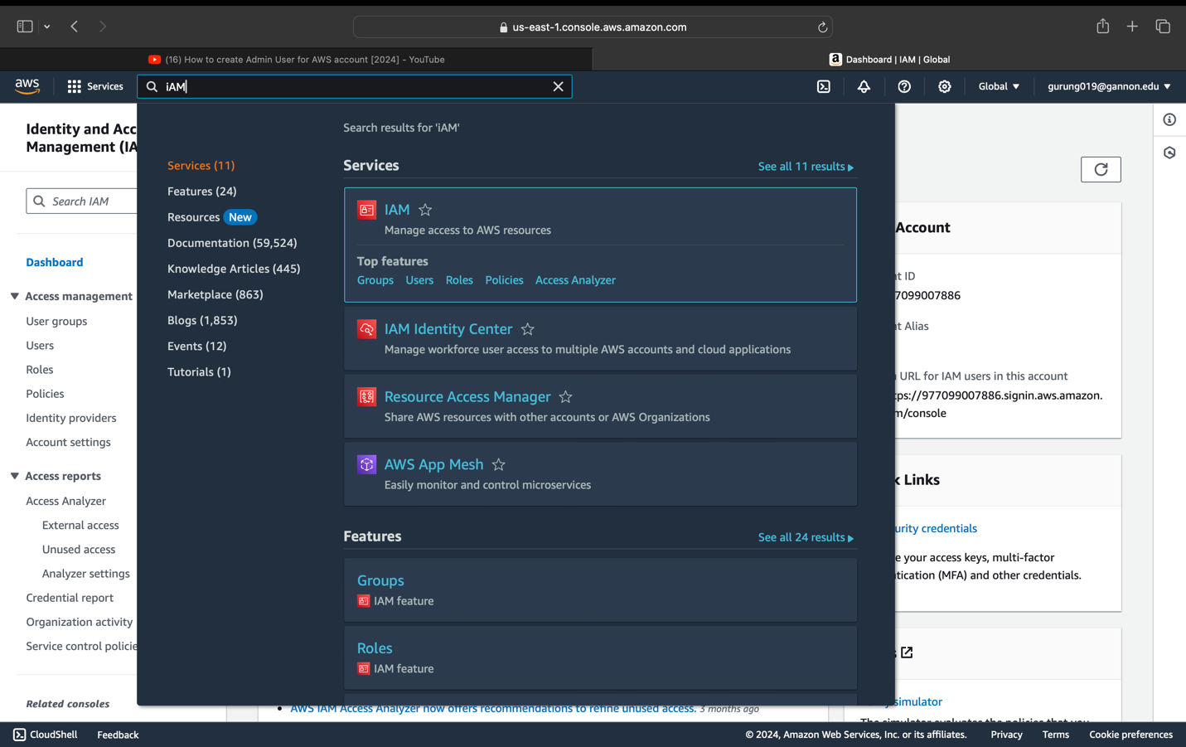

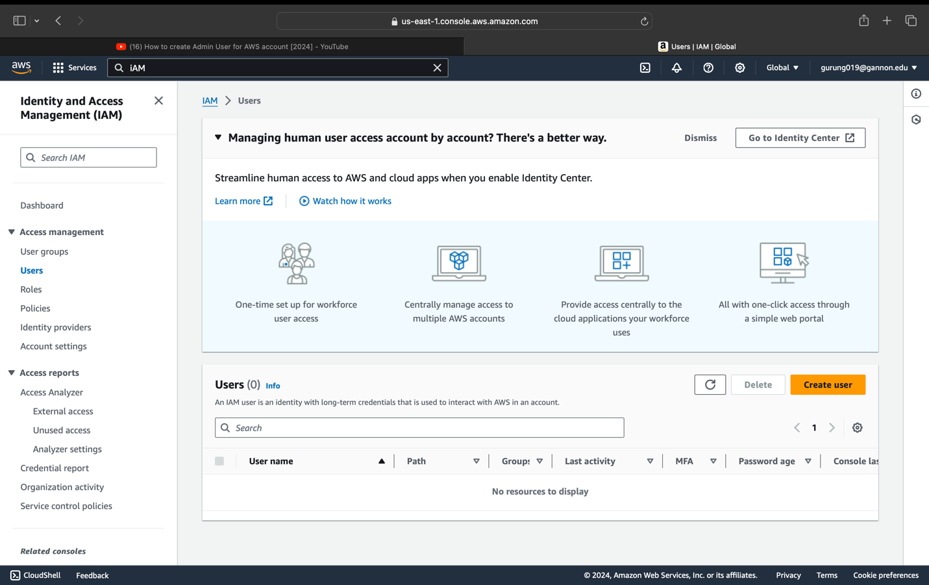

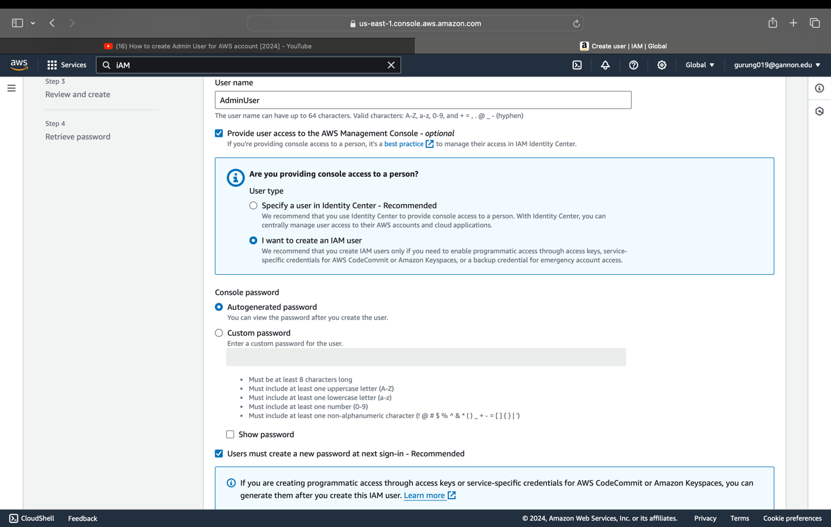

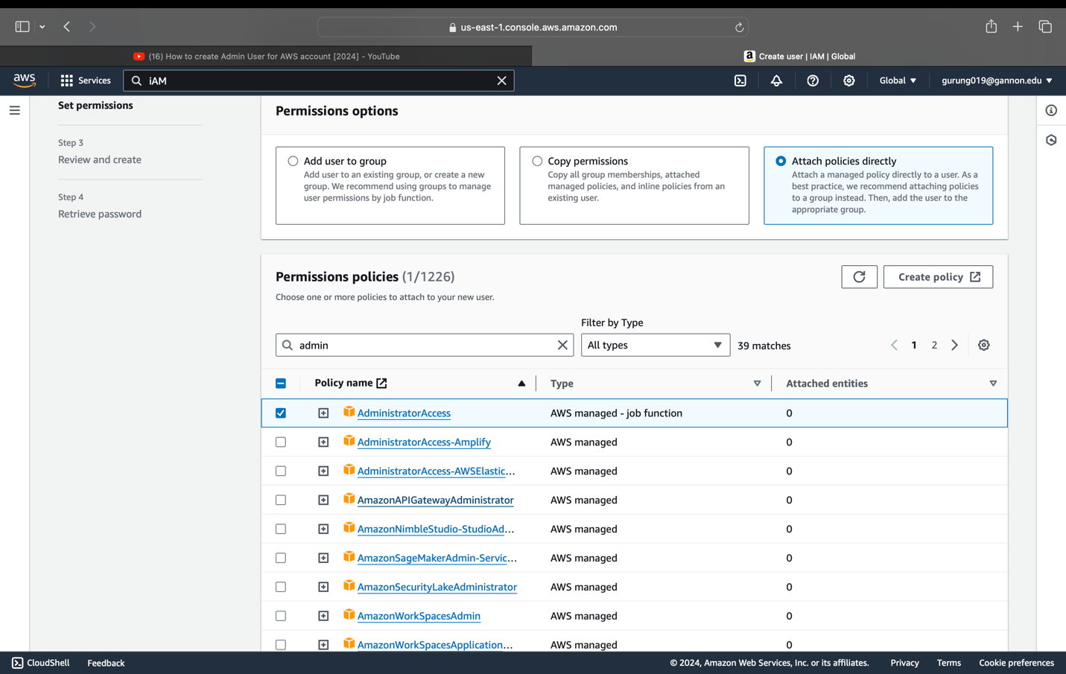

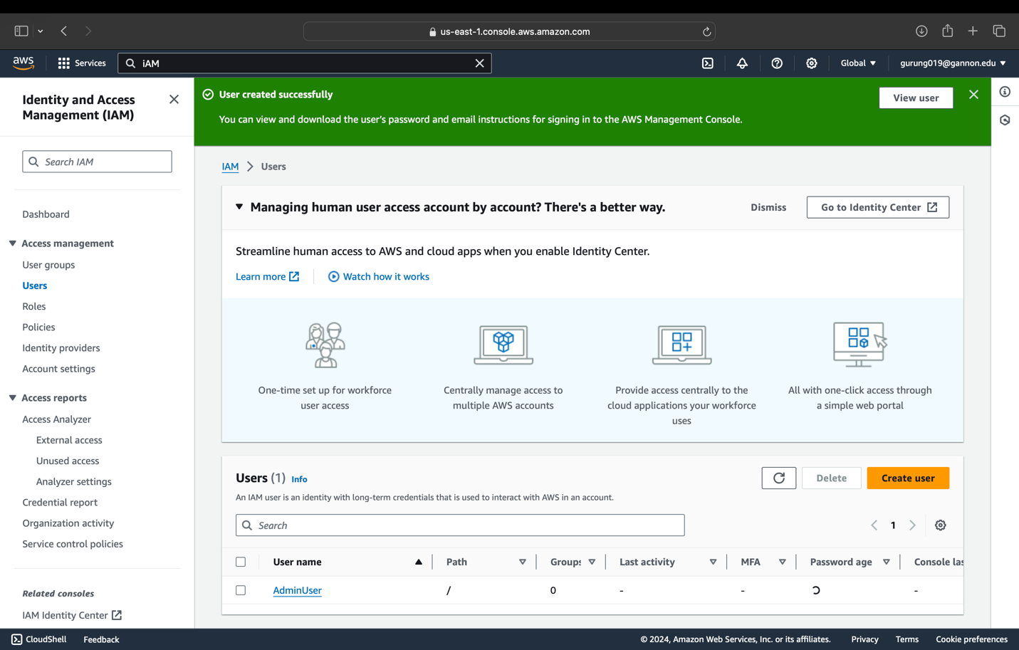

Creating group, attach AWS admin policy to group, attach group to user

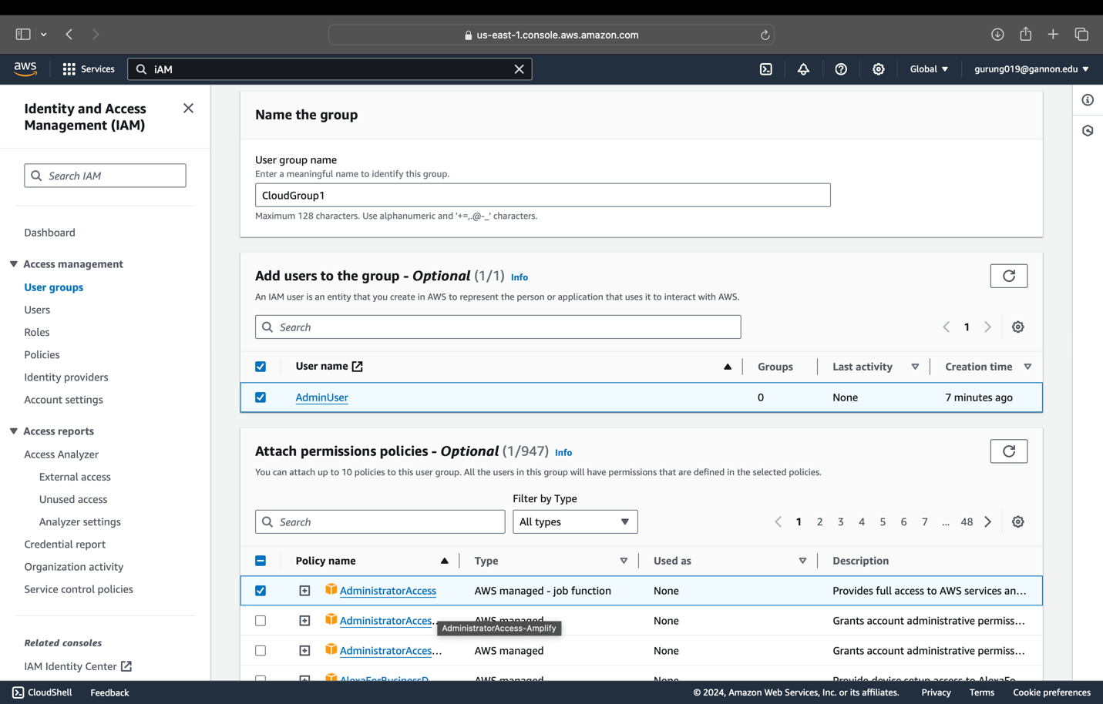

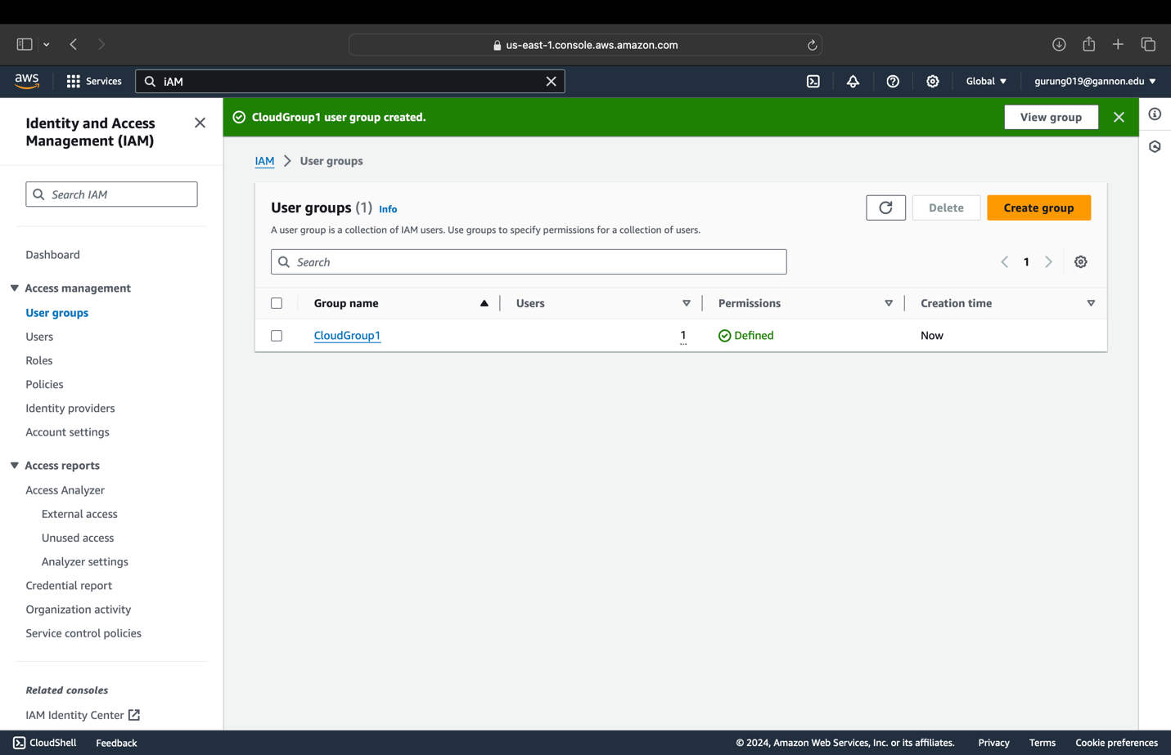

**Please fill in to complete the exercise**

Student Name: Kunga Nyima Gurung

Gannon Email: gurung019@gannon.edu

Screenshot of login to AWS account with AWS Account ID showing:

AWS Account ID: 977099007886

*Please provide a screenshot of AWS configuration showing IAM group with attached IAM policy.

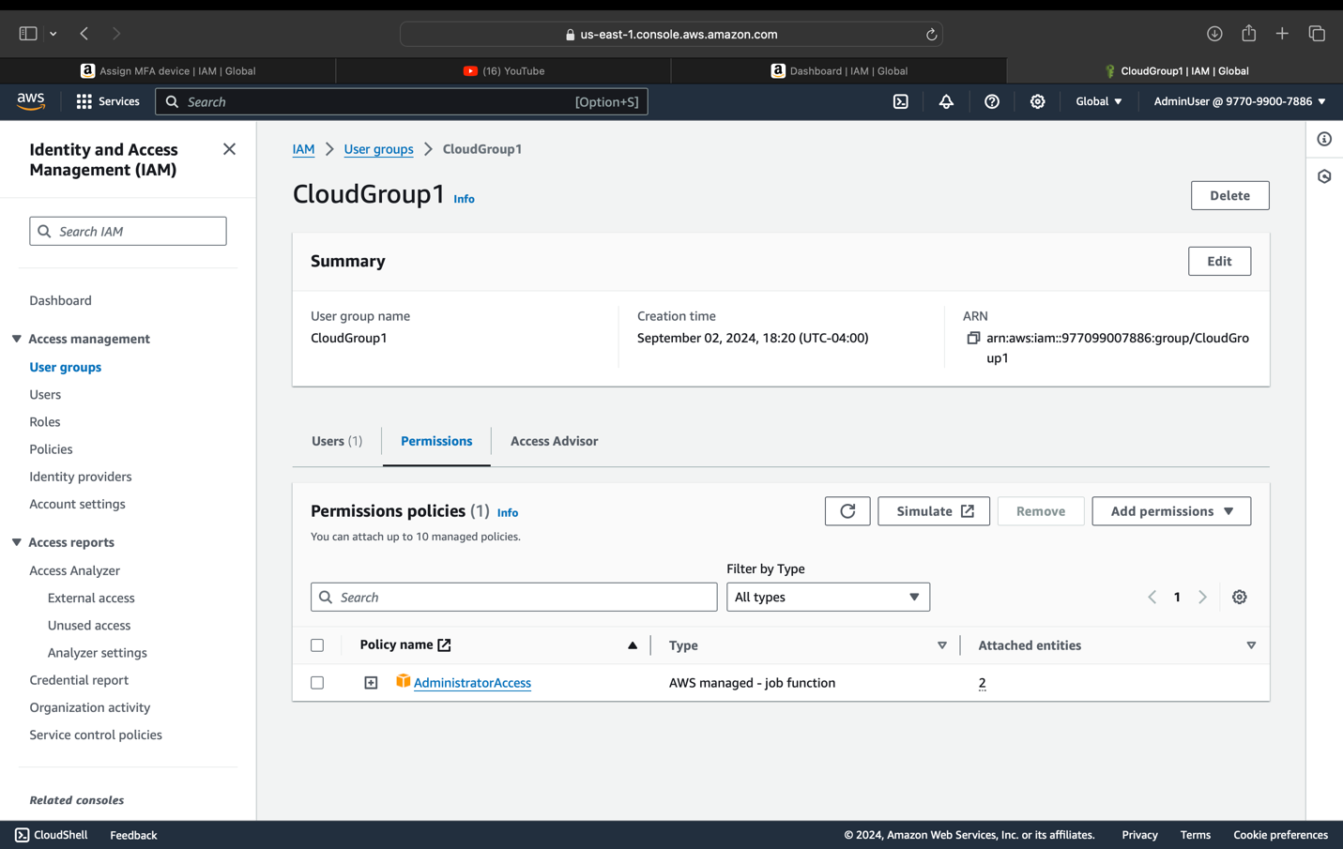

IAM Admin User that is in the IAM group, multi factor authentication enabled for your IAM user using Google Authenticator as a virtual token.

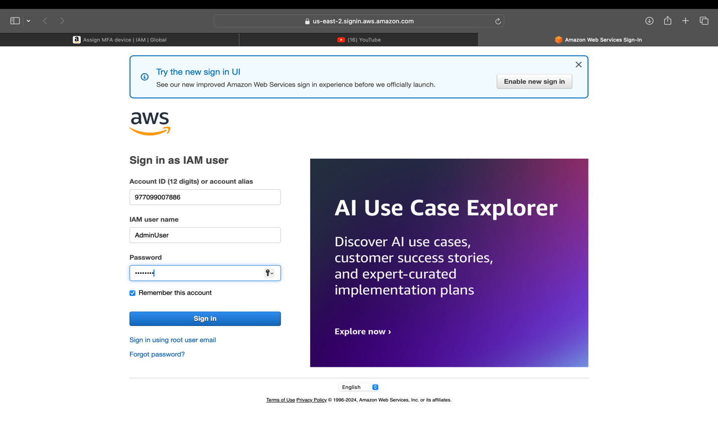

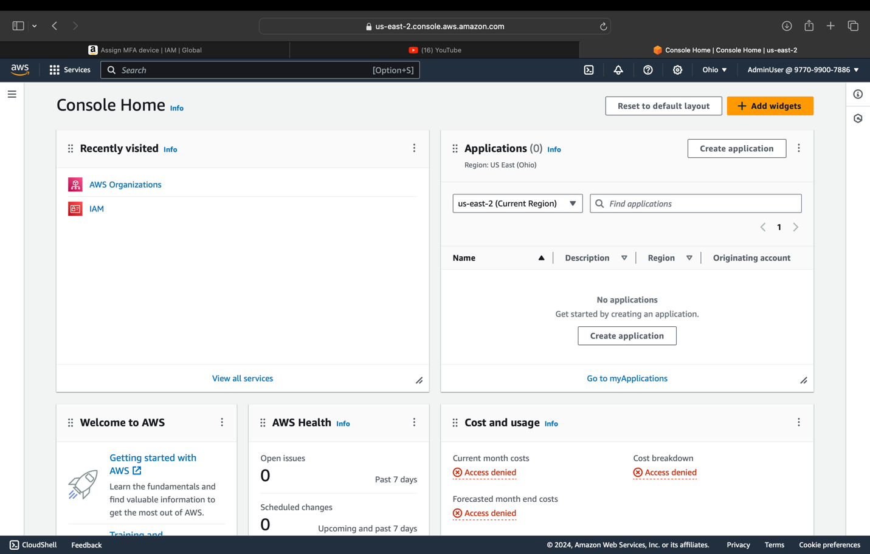

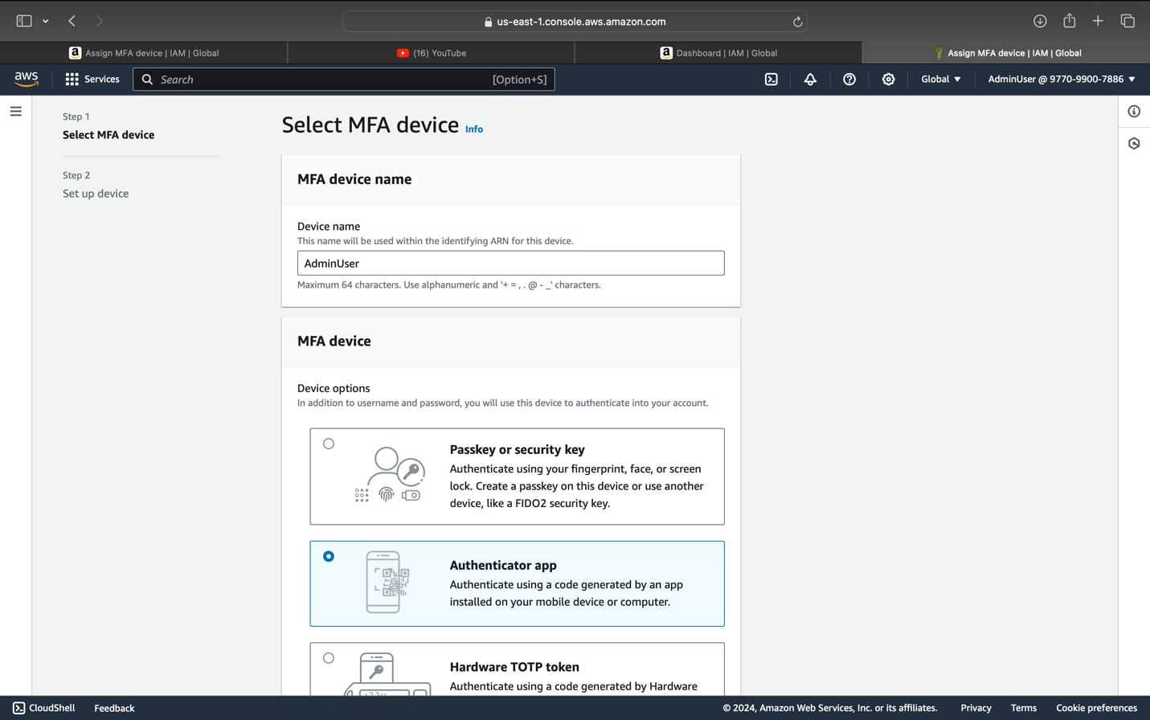

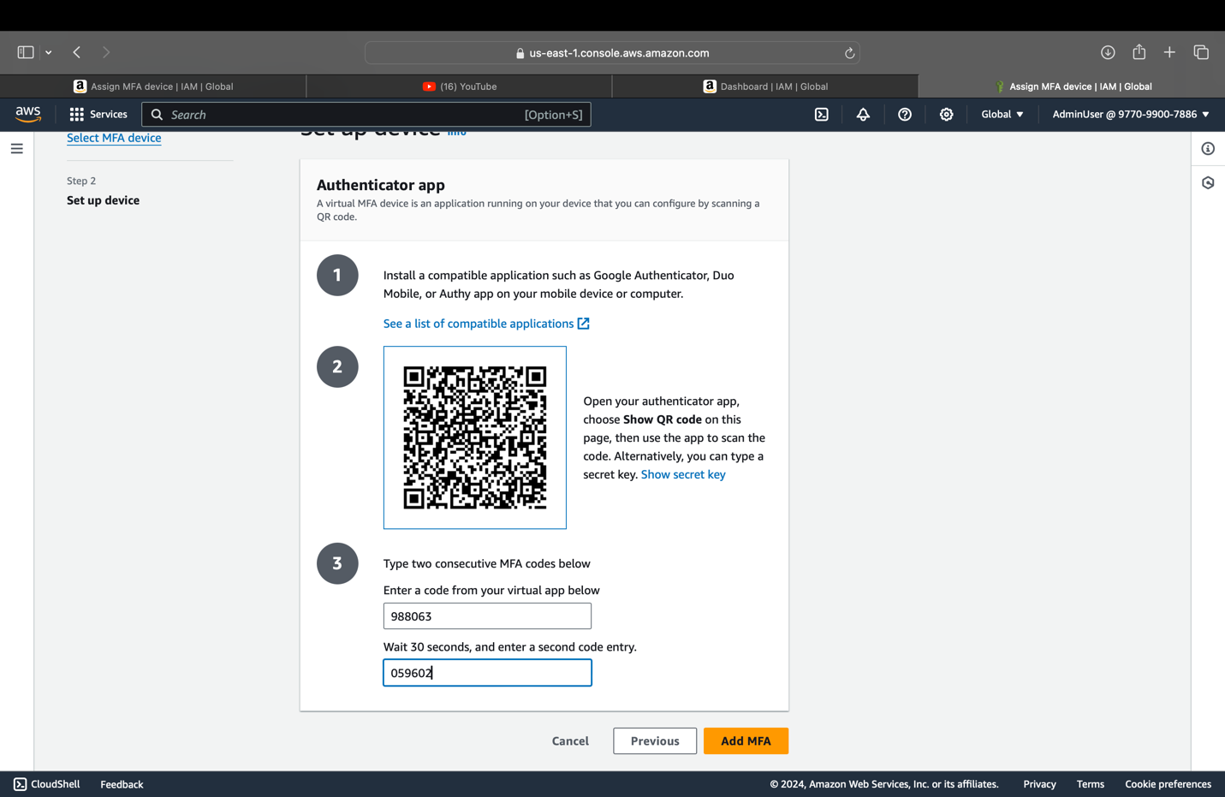

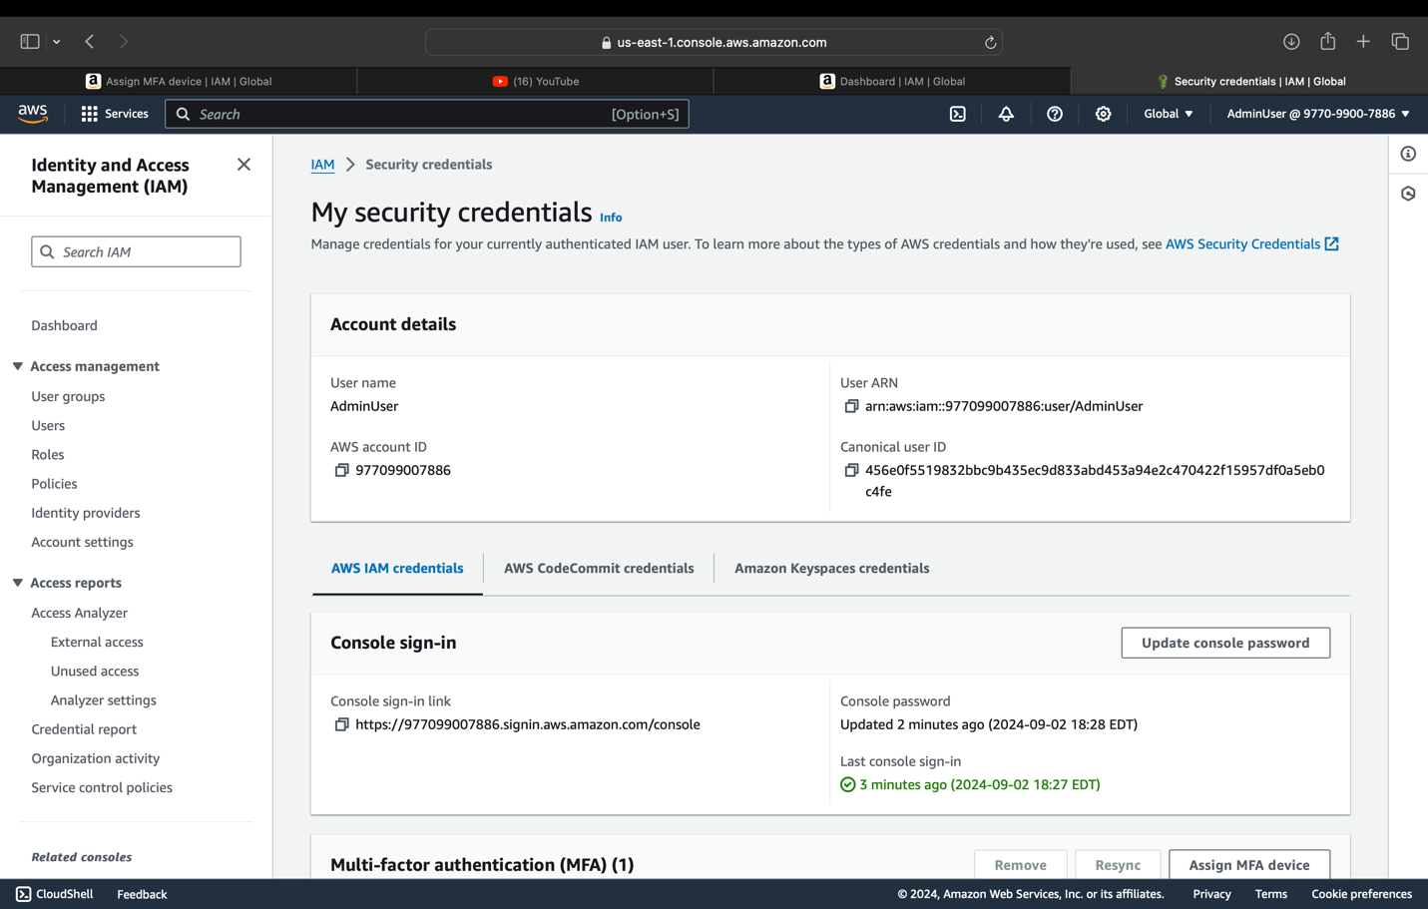

**P3: Task #2: Secure AWS account**

**\*Login as the root user to finish this configuration instead of your new IAM user**

When you first create an Amazon Web Services (AWS) account, you begin with a single sign-in identity that has complete access to all AWS services and resources in the account. This identity is called the AWS account root user and is accessed by signing in with the email address and password that you used to create the account. AWS strongly recommend that you do not use the root user for your everyday tasks, even the administrative ones. Instead, adhere to the best practice of using the root user only to create your first IAM user. Then securely lock away the root user credentials and use them to perform only a few account and management tasks.

There are two steps required to consider your root account secure.

* Activate MFA on your root account
* Apply an IAM password policy

**Step 1: Login to AWS console and navigate to IAM.**

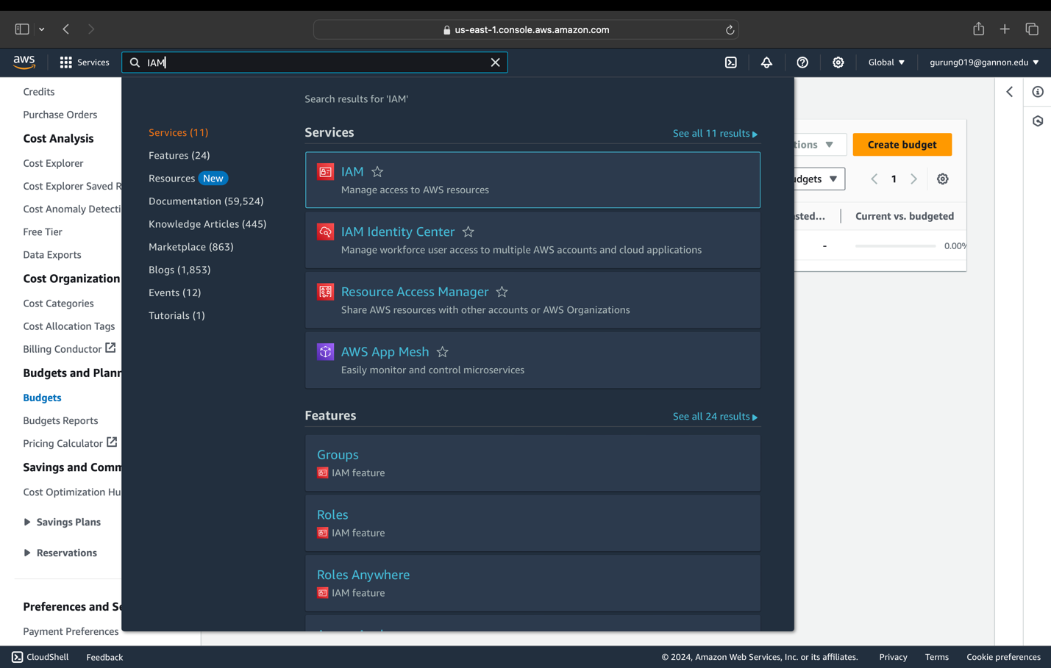

**Step 2: Enable MFA for your root user:**You can use Google Authenticator on your phone as a virtual token.

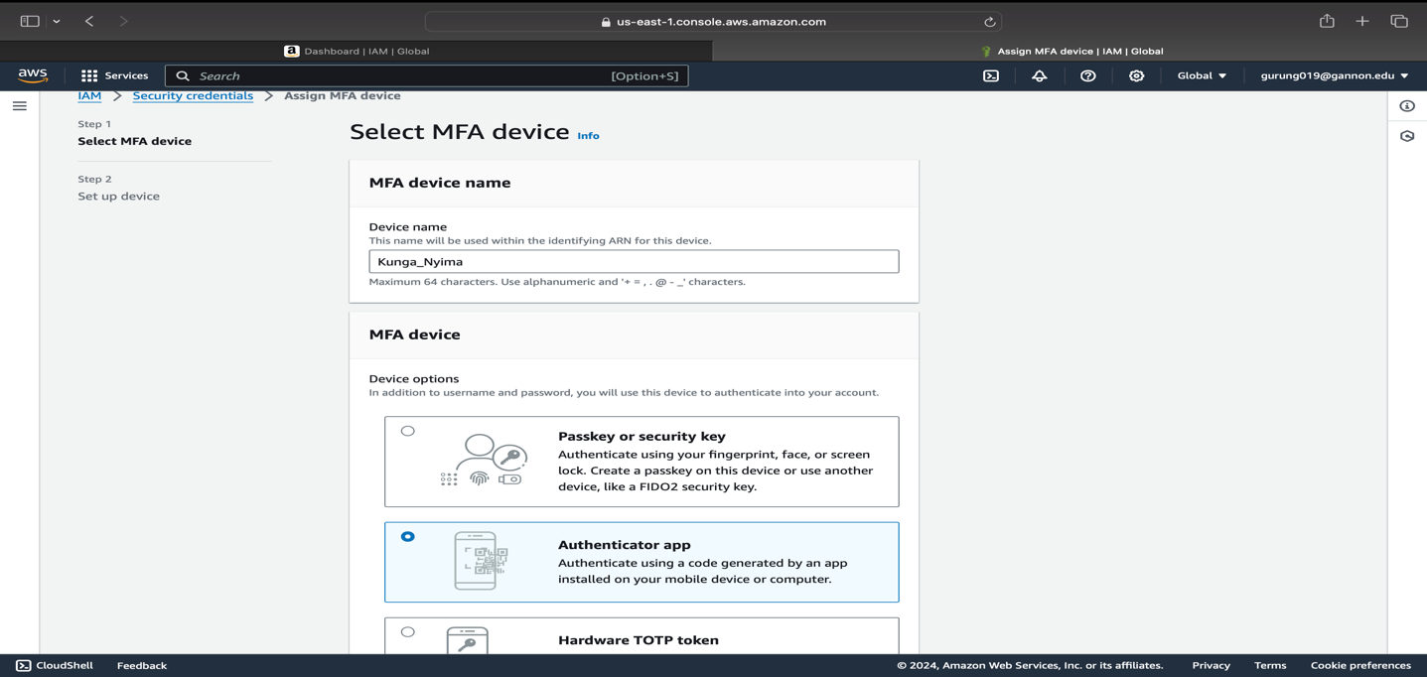

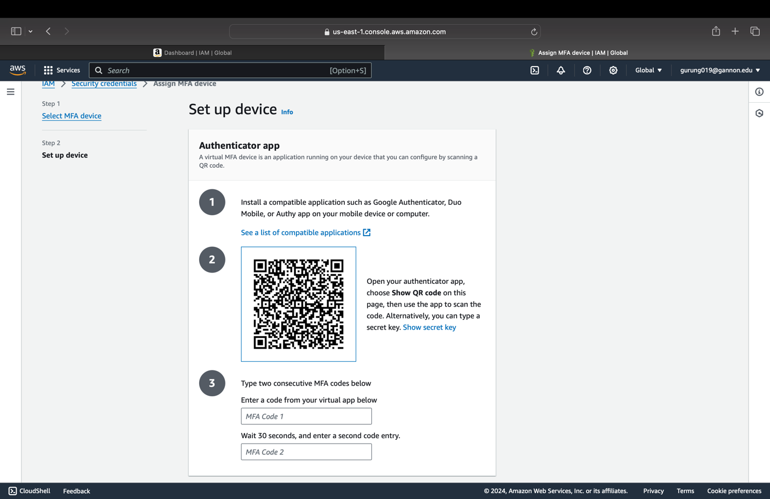

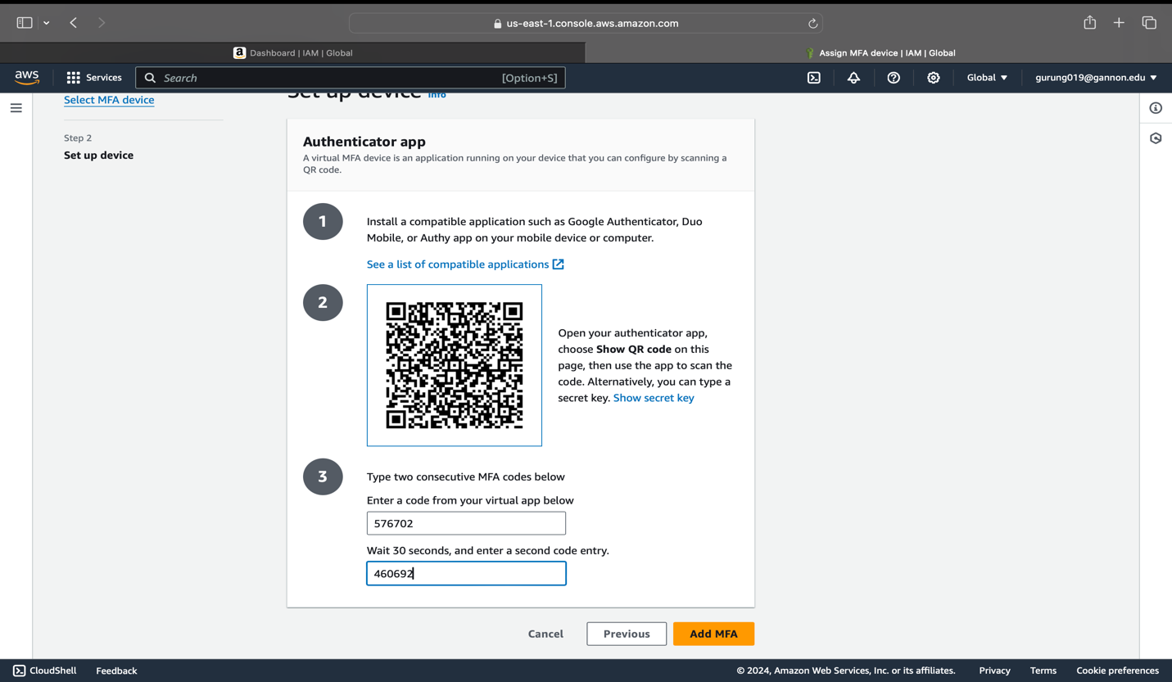

-It will allow you to scan the QR code and enter two MFA codes into the boxes

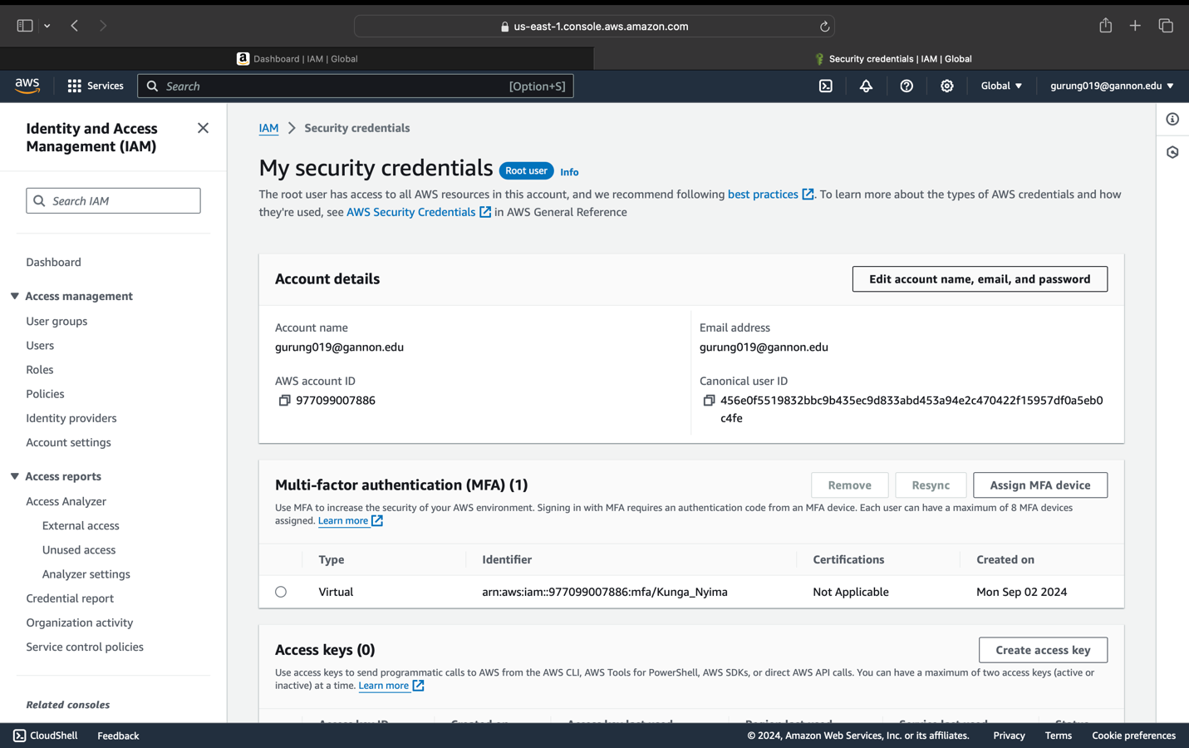

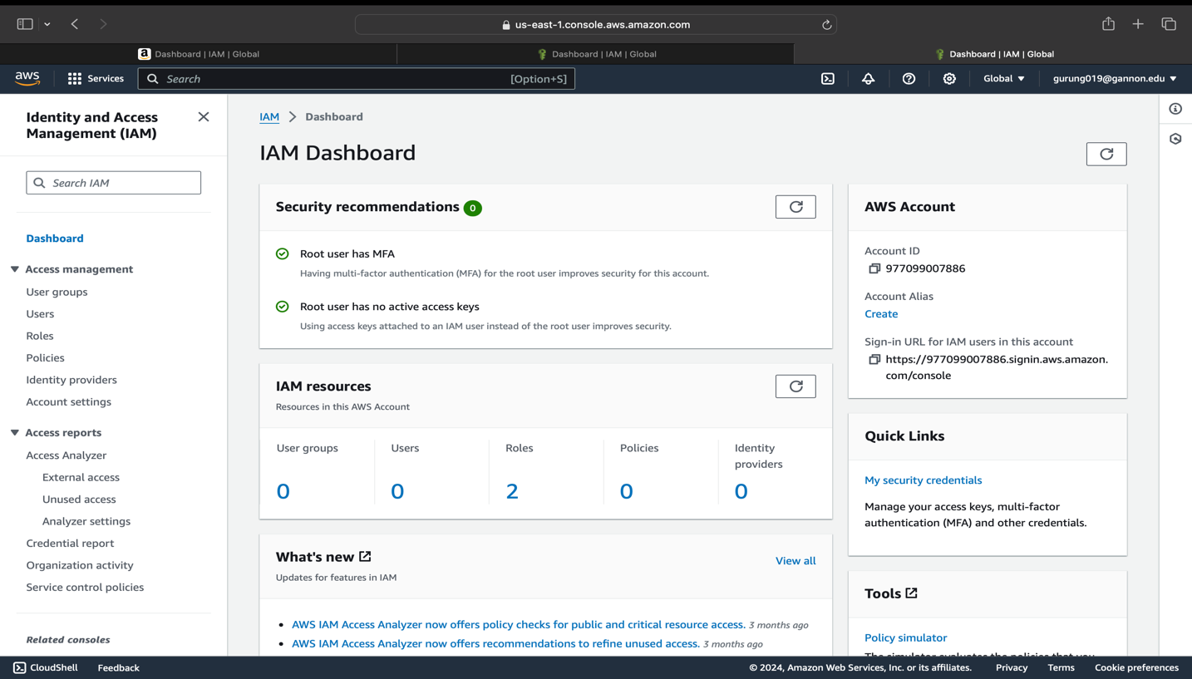

**Step 3: Set IAM password policy and click ‘Apply password policy’.**

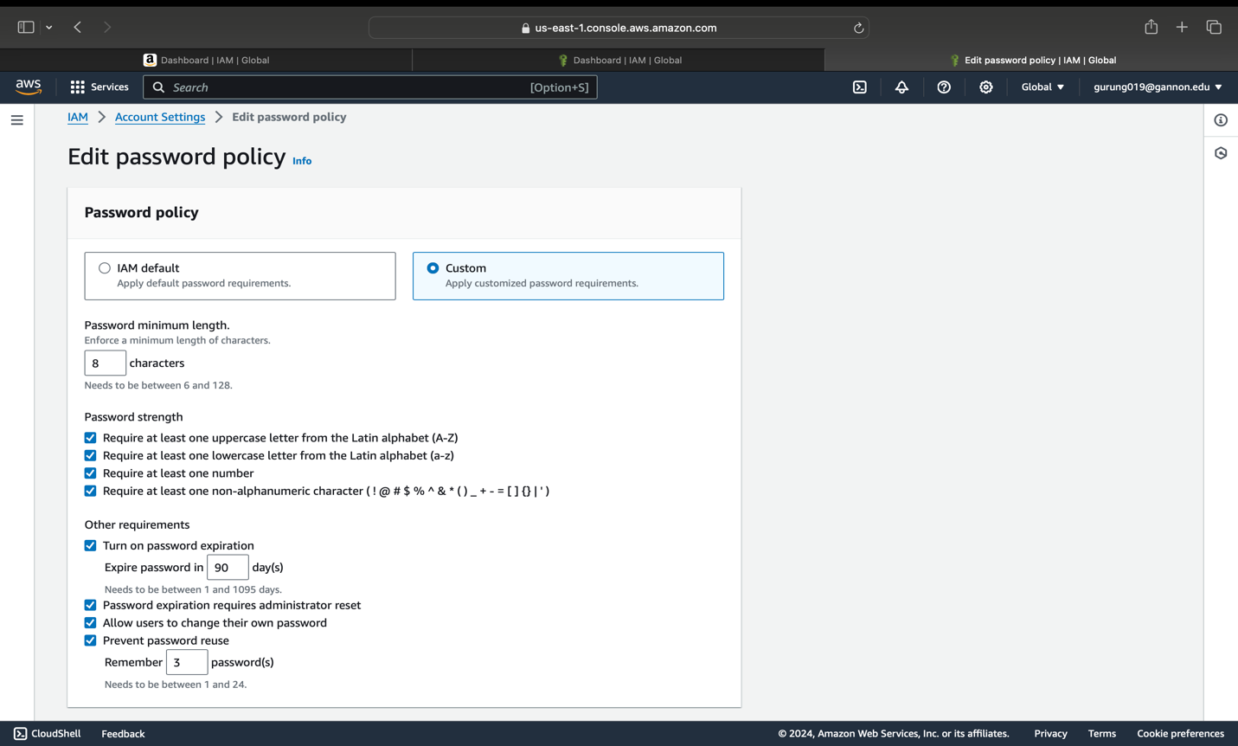

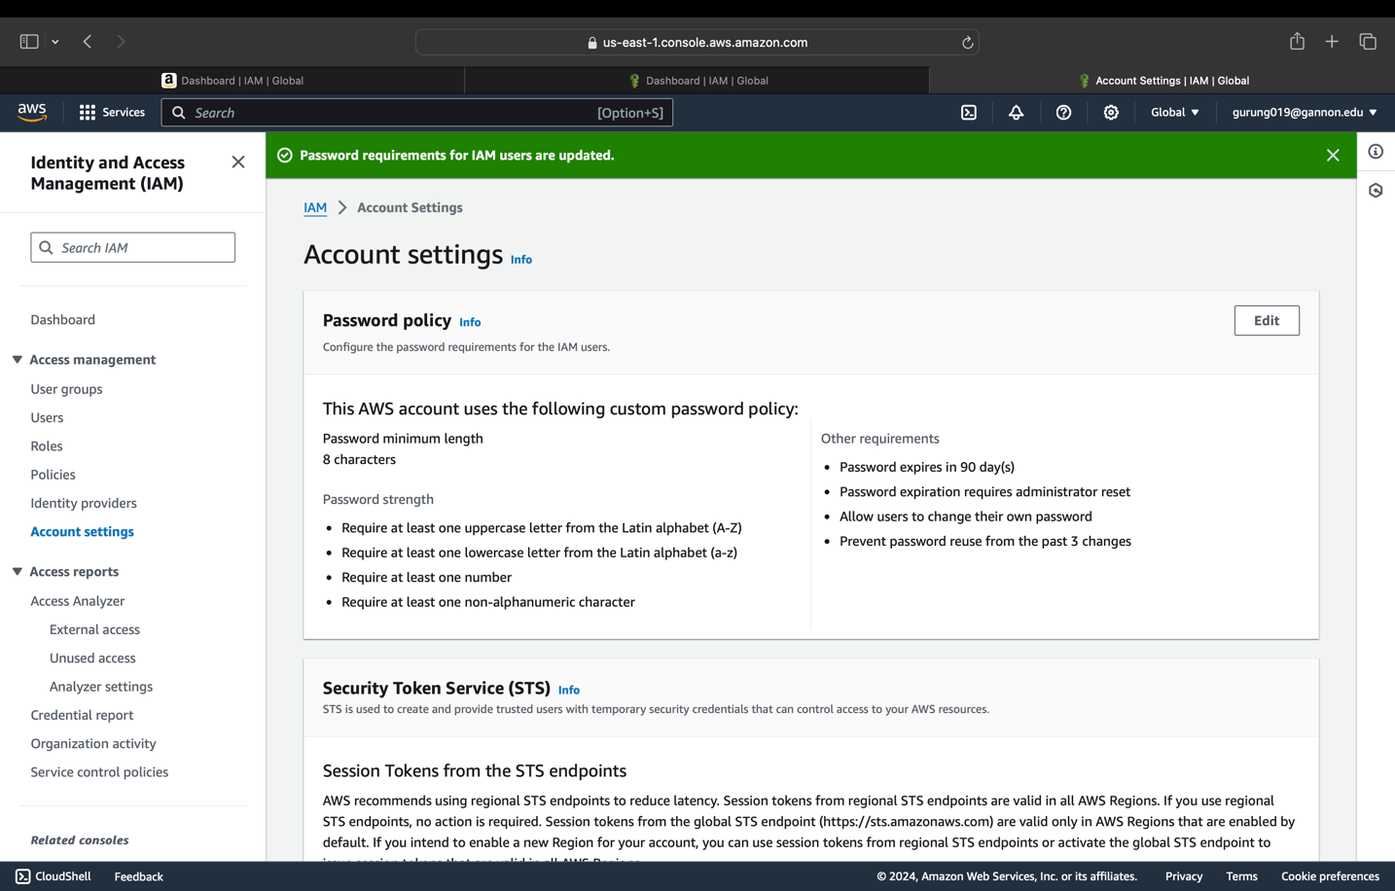Congratulations, your root account has been secured successfully.

**Please fill in to complete the exercise**

*Please provide a screenshot of password policy, and MFA enabled for your root user

Student Name: Kunga Nyima Gurung

Gannon Email: gurung019@gannon.edu

Screenshot of login to AWS account with AWS Account ID showing:

AWS Account ID: 977099007886

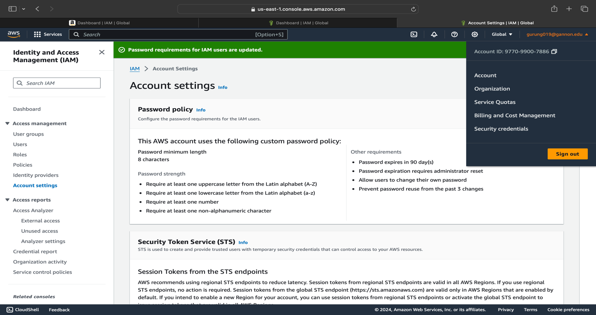

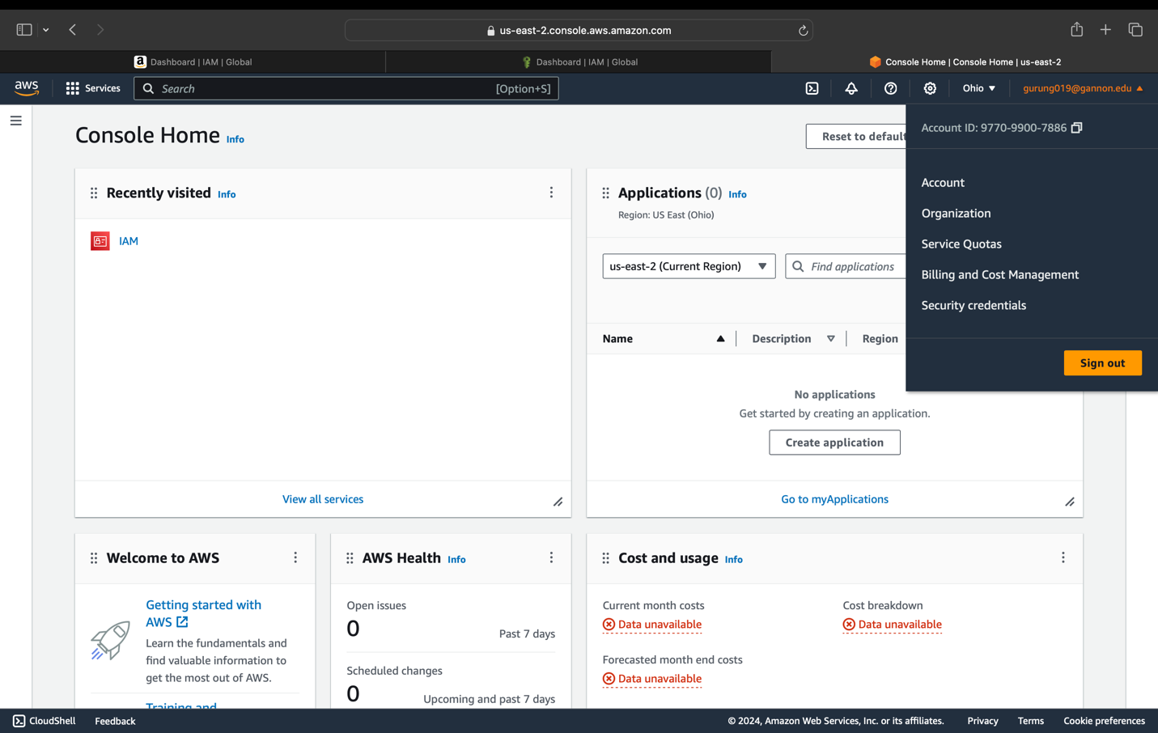

**Problem #4 (5pts)**

**P4: Task #1: Setup a Tag policy on your new AWS account**

Tag policies are a type of policy that can help you standardize tags across resources in your organization’s accounts. In a tag policy, you specify tagging rules applicable to resources when they are tagged.

For example, a tag policy can specify that when the CostCenter tag is attached to a resource, it must use the case treatment and tag values that the tag policy defines, in order to be considered compliant. A tag policy can also prevent noncompliant tagging operations on specified resources.

Using tag policies involves working with AWS Organizations and AWS Resource Groups:

AWS Organizations - When signed in to the organization’s master account, you use Organizations to enable the tag policies feature. You must sign in as an IAM user, assume an IAM role, or sign in as the root user (not recommended) in the organization’s master account. Then you can create tag policies and attach them to the organization entities to put those tagging rules in effect.

AWS Resource Groups - When signed in to an account in your organization, you use Resource Groups to find noncompliant tags on resources in the account. You can correct noncompliant tags in the AWS service where you created the resource.

**Create a Tag Policy**

We will create a policy containing two tagging rules. Both tag rules, environment and business unit, will require specific values and syntax in order to be compliant.

1. Navigate to the AWS Organizations service using the navigation bar and select Policies on the left-hand side and click “Tag policies”

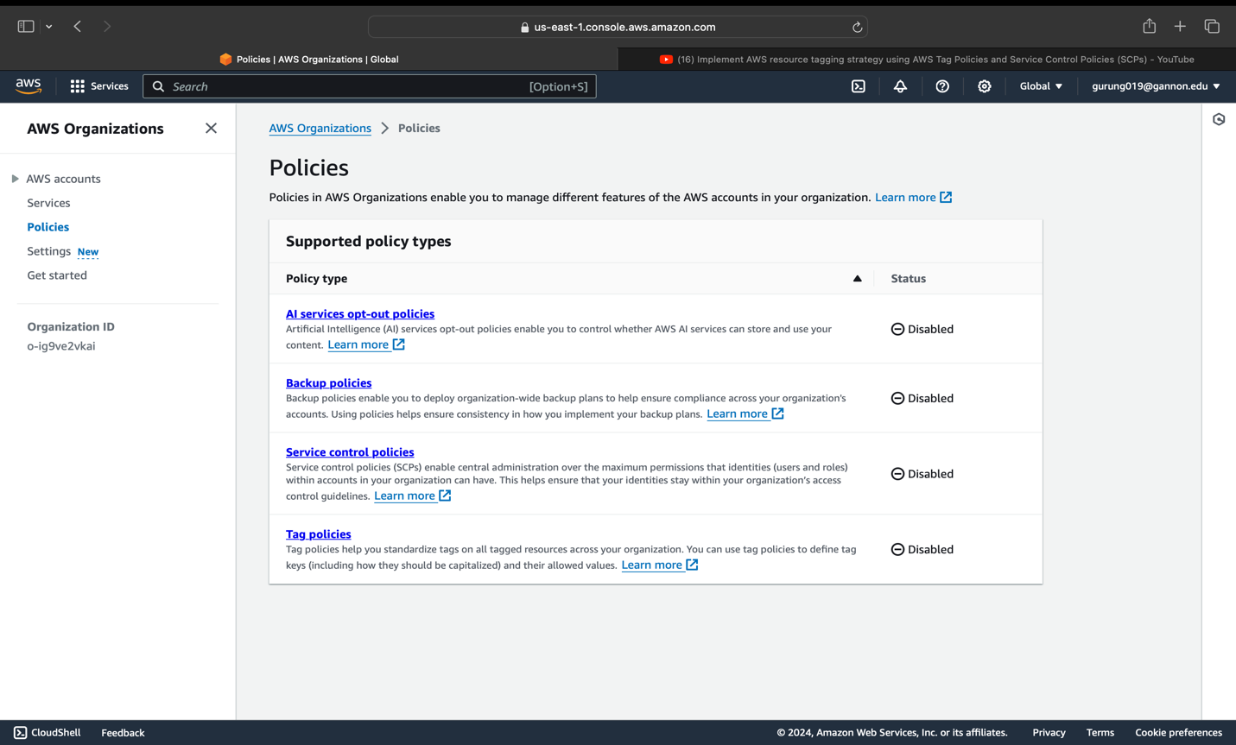

1. Within the Tag policies page select “Create Policy”. (If this is your first-time using tag policies, you may need to “Enable tag policies” prior to clicking create policy).

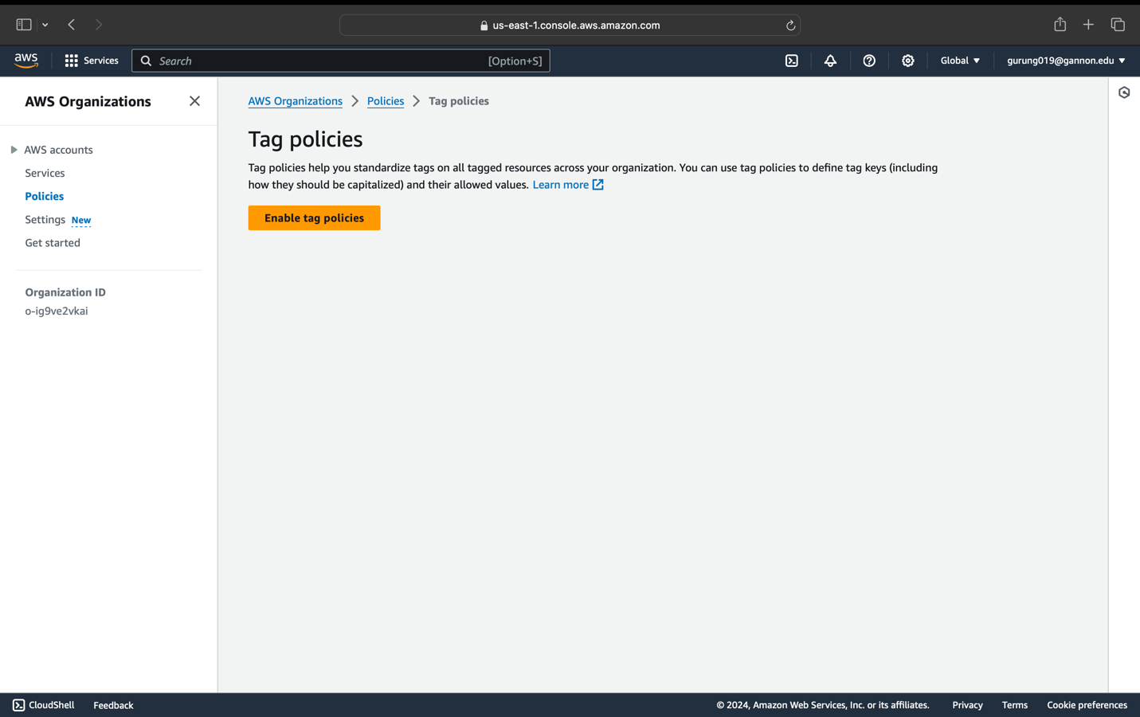

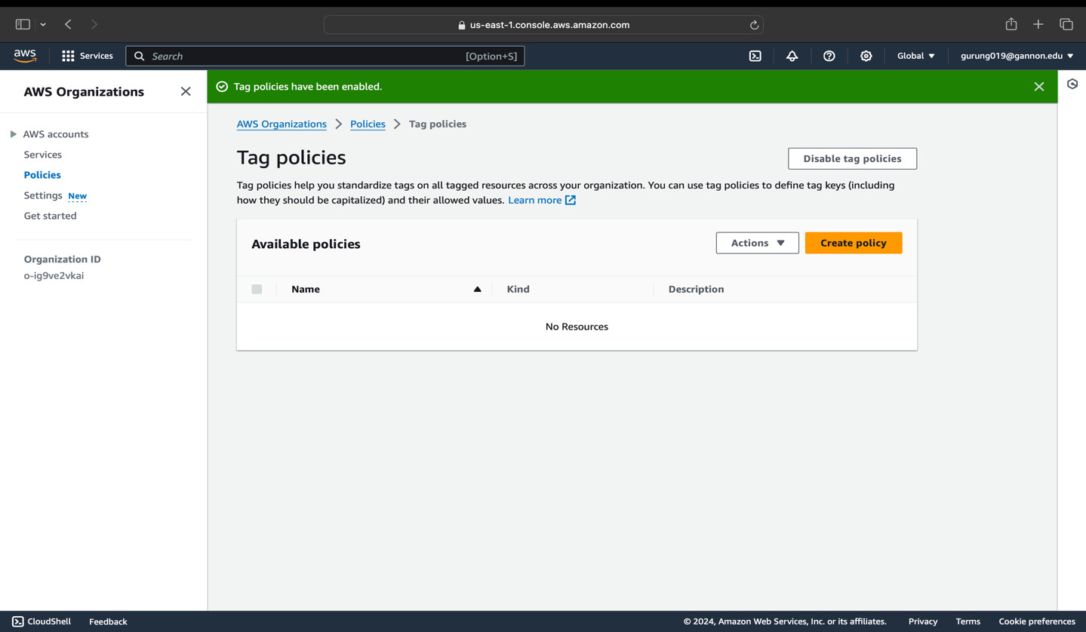

1. On the Create policy page, under both the Policy name and Policy description enter “cost_allocation”

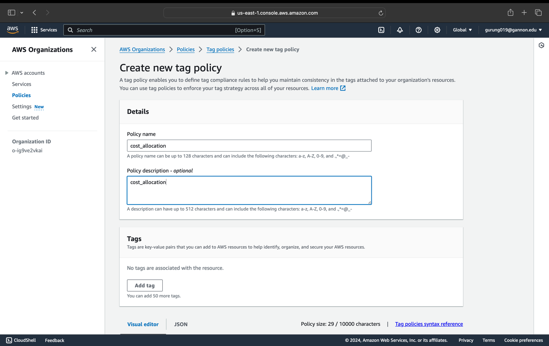

1. In the New tag key 1 section, under Tag key, type “environment”. Under Tag value compliance click the box “Specify allowed values for this tag key, the click “Specify values”

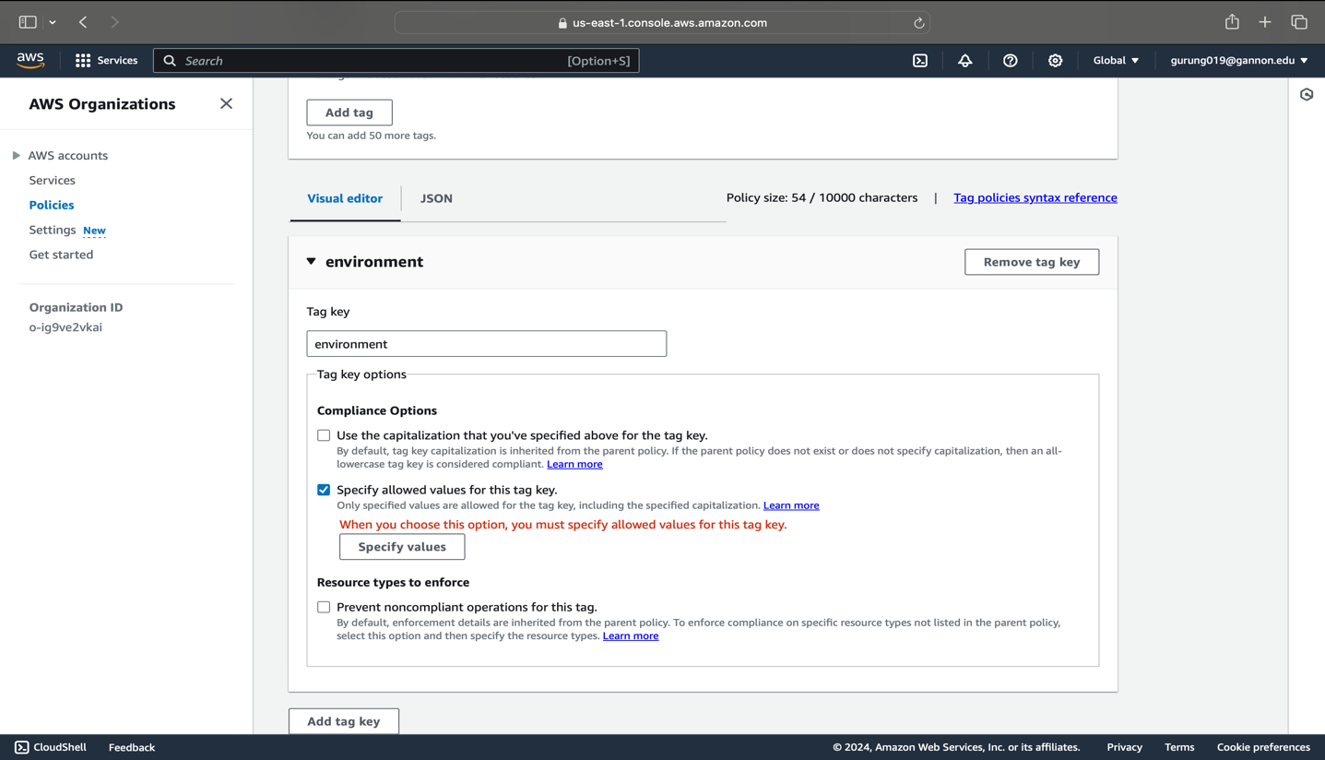

1. Add the following values (each separately): prod, dev, uat, test and click Save Changes

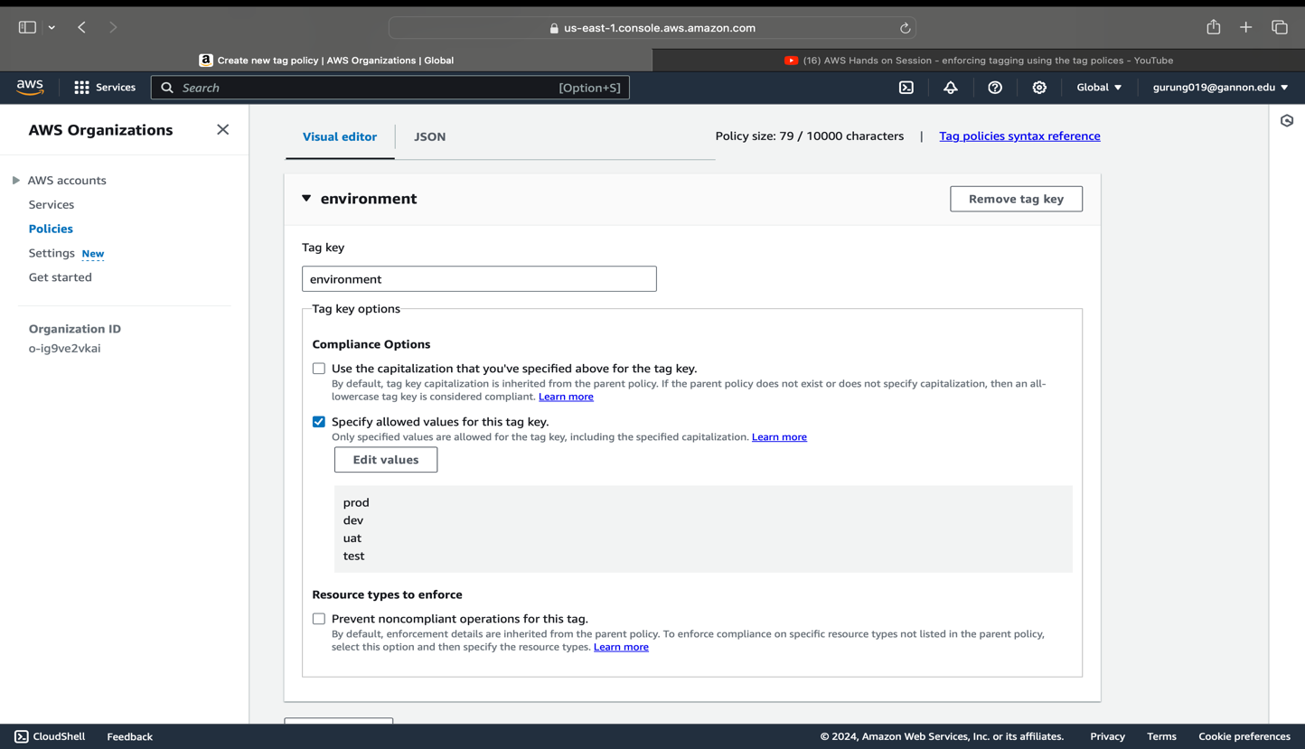

1. Click “Add tag key” to create another tag key. Follow steps 4 – 7 and name this tag key “business_unit”, and add the following values: marketing, research, sales, operations and click Create Policy

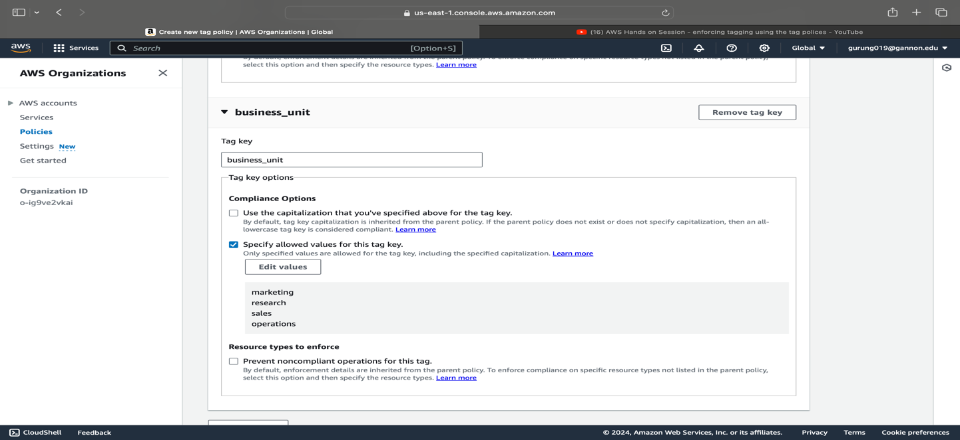

**Please fill in to complete the exercise**

Student Name: Kunga Nyima Gurung

Gannon Email: gurung019@gannon.edu

Screenshot of tag policy with your AWS account ID in the screenshot from the top menu

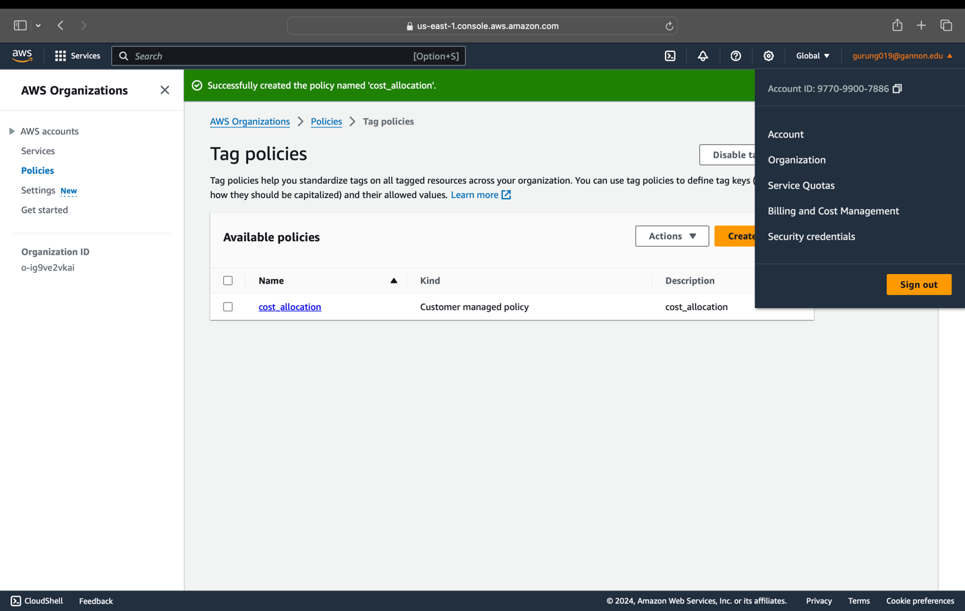

Note: *Please delete your tag policy after this exercise which you created in P4:Task #1.

Problem #5 (5pts):

P5: Task #1: Respond to the prompt below  
Why would you choose to leverage a cloud provider vs. build data centers when starting a new business?   
-Grading will be based on the quality criteria for assignments outlined in the syllabus.